**Issue 8**: Field to enter the mobile number is not present in the address fields

**Description**: If this screen is part of an online shopping site, it would be good to include the field to enter the mobile number as well, so that the package will be delivered hassle free.

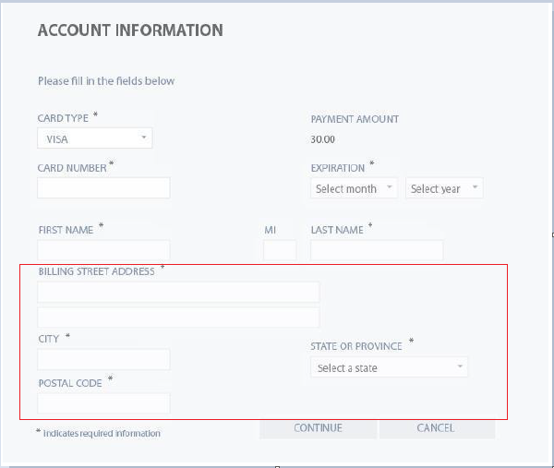

**Expected Behavior**: A field to input mobile number should be present in the address form area

**Severity**: Moderate